**WEEK 3**

1)Find the linear relationship between the number of hours a student has studied and the percentage he has scored.

|  |  |  |  |  |  |  |  |  |  |  |
| --- | --- | --- | --- | --- | --- | --- | --- | --- | --- | --- |
| % | 0 | 10 | 20 | 30 | 40 | 50 | 60 | 70 | 80 | 90 |
| hours | 1 | 3 | 2 | 5 | 7 | 8 | 8 | 9 | 10 | 12 |

2) Use polynomial regression to show the growth in the salary of a companies incrementing post is not exactly linear with the dataset given below.

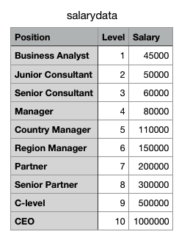

1. The dataset given in the notepad(Q3 FISH) is a record of 7 common different fish species in fish market sales. With this dataset, a predictive model can be performed using machine friendly data and estimate the weight of fish can be predicted.

Which regression model would be best suited for the dataset?

Give reason.